Human Respiration Laboratory Experiment
By

Alison L., Thurow, Brittany Baierlein, Rachel C. Holsinger and Robin L. Cooper
Department of Biology, University of Kentucky, Lexington, KY 40506-0225, USA.

Purpose:
The goal of this laboratory exercise is to understand respiratory function in humans and how to calibrate values obtained with independent measures. Relate the various respiratory functions for a normal person and one under a pathological condition such as having an asthmatic attack.

Introduction:
Respiration is responsible for gas exchange throughout the entire body. This occurs in the lungs where blood exchanges carbon dioxide for oxygen and in the tissues of the body where the oxygen is given up by the blood for carbon dioxide. Every time gas is exchanged in the body, whether it is over an alveoli or another body tissue, a system of capillaries provide a surface which the gases can diffuse over. Ventilation is the act of breathing, or inhaling and exhaling. The active part of breathing is inhaling; this is accomplished when the diaphragm contracts producing negative pressure in the lungs which causes air to flow into the lungs. Exhaling happens when the lungs return back to their normal size and the air is forced out as a result, this makes exhaling a passive process.

To measure respiration in humans there are a few terms that are necessary to understand. Total lung capacity, which is the total amount a person’s lungs can hold, is divided into various volumes and capacities according to the ventilatory process. This volume is difficult to measure because of the residual volume (RV). The amount of air that remains trapped in the lungs after a maximal expiratory effort. The tidal volume (TV) is the normal amount of air that is exchanged between inhaling and exhaling during normal quiet breathing. Average values for a 72 kg individual is 500mL Inspiratory Reserve Volume (IRV) is the volume of air forcefully inspired above and beyond that taken at the end of a normal quiet inspiration. The average IRV for a 72 kg individual is 3.0 L. Expiratory Reserve Volume (ERV) is the amount of air that can be forcefully exhaled following a normal quiet expiration and the average volume is 1.0 L. The tidal volume plus the inspiratory reserve volume plus the expiratory reserve volume plus the reserve volume is the total lung capacity (TLC) and average volume is 5.8 L. The vital capacity (VC) is the amount of air that is exchanged between inhaling and exhaling when the person tries to inhale and exhale as much as they can. It can be measured by adding the tidal volume plus the inspiratory reserve volume plus the expiratory reserve volume. The average volume is 4.5 L. See figure 1 for a visualization of these volumes.

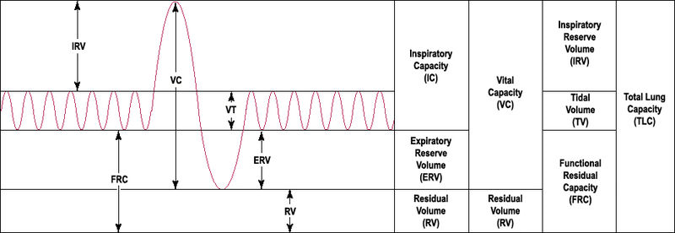
Figure 1: Lung Volumes (public domain).

Materials:

Item | Needed Per Group
Ruler for balloon measure | 1
Duct tape -clear | A 4 inch piece
Extra mouthpieces and disposable air filters for | each volunteer.
A computer system Chart software | 1
Spirometry extension PowerLab | 1
Spirometer Pod | 1
Respiratory flow head (1000 L/min) with connection tubes | 1
Clean bore tubing | 1 set
Disposable filters | 1
Disposable vinyl mouthpieces | 1
Nose clip | 1
Balloon | 1

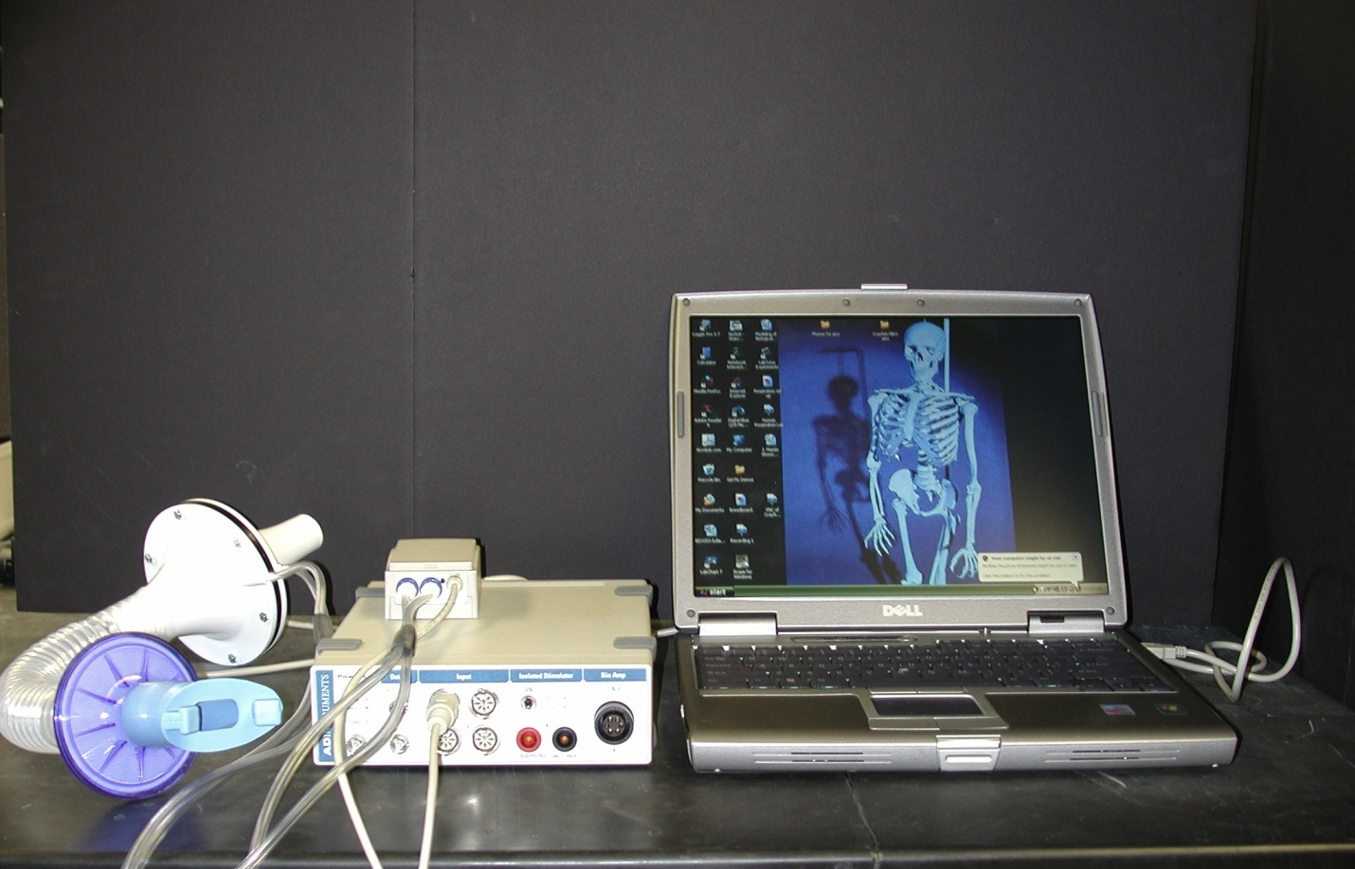
PowerLab Data Acquisitioner
Spriometer Pod
Flow Head with mouthpiece and tube connections

Figure 2: The image above shows the setup for the respiration experiment.

Exercise 1: Becoming familiar with the equipment
- Connect the Spirometer Pod to Input 1 on the PowerLab. Since the Spirometer Pod is sensitive to temperature and tends to drift during warm-up, turn on the PowerLab for at least 5 minutes before use. To prevent temperature drift due to heating of the Pod, place it on a shelf or beside the PowerLab, away from the PowerLab power supply.
- Connect the two plastic tubes from the respiratory flow head to the short pipes on the back of the Spirometer Pod (Figure 2).
- Attach Clean Bore tubing, a filter and mouthpiece to the flow head.
- Open software, Chart. Close the welcome center box (click x on top right of box). Click on Channel settings. At bottom of box select to use only 1 channel. Then OK. Now go to right side and select 500 mV for scale. 1 K/sec is fine for acquisition rate.
- See top of menu box select ‘window’ and click on ‘data pad’ on drop down. Grab side of box and reduce size so only Channel 1 is showing. Slide next to ‘chart view’. Might need to reduce size of ‘Chart view’ window. Click on Channel 1 in data pad. Click on ‘integral’ then ‘OK’. Now Channel 1 measures the area under the curve. THESE WILL BE THE MEASURES TO RECORD IN YOUR TABLES.
- Leave the flow head apparatus undisturbed on the bench and click the Zero Pod button from the CHART software menu. This will reset the offset of the Flow channel to zero.
- Put the nose clip on the volunteer’s nose. This ensures that all air breathed passes through the mouthpiece, filter and flow head.
- Click Start. The volunteer can now put the mouthpiece in his or her mouth, and hold the flow head carefully with two hands. In order to calculate volume from the flow recording correctly it is crucial that recording be started prior to breathing through the flow head (Figure 3).
- Observe the trace. The signal should show a downward deflection on expiration. If the signal deflects upward, stop recording and either reverse the orientation of the flow head, or swap the tubular connections to the Spirometer Pod.
- When the volunteer has become accustomed to the apparatus and is breathing normally through it, stop recording.
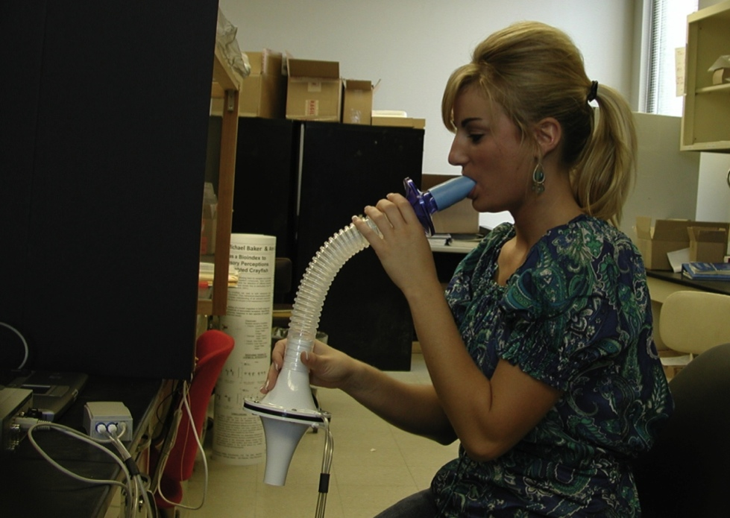

Figure 3: The image above shows the proper use of the flow head for the respiration experiment.

Exercise 2: Lung Volume and Capacities
- Zero the Spirometer Pod using the Zero Pod button. Remember that the flow head must be left undisturbed on the bench during the zeroing process.
- Click Start. Once recording has started ask the volunteer to replace the nose clip and breathe normally through the flow head. Record normal tidal breathing for 1minute.
- During recording add the comment "Normal tidal breathing" to the data.
- After the tidal breathing period and at the end of a normal tidal expiration, ask the volunteer to inhale as deeply as possible and then exhale as deeply as possible. Afterwards, allow the volunteer to return to normal tidal breathing then stop recording.
- Add the comment "Lung volume procedure" to this deep breath.
- Examine the normal tidal breathing data. Determine where the data appears to be the most consistent and count the number of breaths per minute. Record this data in Table 1.
Table 1
Respiratory Parameter | Abbreviation | Units | Experimental
Frequency | f | (breaths /min)

- Determine the volume (non-calibrated to volume for now) of a single tidal inspiration by dragging the cursor over the top half of the full Tidal Volume. The area you are interested in measuring of the trace should appear darkened. Then add to data pad ‘CTRL D’ on key board. Then do the same for the bottom half of the trace. Add the two areas of absolute values (e.g. both positive values) and this is the total area under for the TV for inspiration and expiration. Do this for 3 normal tidal volumes and take an average. Fill in table 2 in the experimental column.

Table 2: Tidal Volume
 | Experimental (mV²) | Calculated (L)
Trial 1
Trial 2
Trial 3
Average

- Determine how to measure the Inspiratory Reserve Volume (IRV) and Expiratory Reserve Volume (ERV). First think how you could measure this from examining the calculations you just performed and from Figure 1 of the various lung volumes. If you performed a Forced Vital Capacity (FVC), which area would one want to measure from the traces?

Exercise 4: Pulmonary Function tests
- Re-zero the Spirometer Pod using the Zero Pod button. Remember that the flow head must be left undisturbed on the bench during the zeroing process
- Click Start. Once recording has started ask the volunteer to replace the nose clip and breathe normally through the flow head.
- Prepare a comment "FVC procedure".
- Have the volunteer breathe normally for 10 to 20 seconds.
- Ask the volunteer to inhale and then exhale as forcefully, as fully and for as long as possible, until no more air can be expired.
- Allow the volunteers breathing to return to normal, then click Stop.
- Your recording should resemble figure 1.
- Repeat this procedure twice more, so that you have three separate Forced Vital Capacity recordings.
- Using the Cursor and the data table and now calculate the area of the three Forced Vital Capacities (FVC). The area you are interested in measuring of the trace should appear darkened. Then add to data pad ‘CTRL D’ on key board. Then do the same for the bottom half of the trace. Add the two areas of absolute values (e.g. both positive values) and this is the total area under for the FVC for inspiration and expiration. Record that data in Table 3.
- Here is a good time to think again about how to measure Inspiratory Reserve Volume (IRV) and Expiratory Reserve Volume (ERV) by area measures (hint: do you also measure or exclude TV?).
Table 3: Forced Vital Capacities
 | Experimental (mV²) | Calculated (L)
Trial 1
Trial 2
Trial 3
Average

Exercise 5: Asthma Simulation
- Remove the filter attachment from the clean-bore tubing.
- Cover the end of the filter with clear duct tape.
- Use a pen or a sharpened pencil to make a hole in the duct tape over the filter about a half centimeter in diameter.
- Reattach the filter to the clean-bore tubing.
- Re-zero the Spirometer Pod using the Zero Pod button. Remember that the flow head must be left undisturbed on the bench during the zeroing process
- Click Start. Once recording has started ask the volunteer to replace the nose clip and breathe normally through the flow head.
- Prepare a comment "FVC restricted".
- Have the volunteer breathe normally for 10 to 20 seconds.
- Ask the volunteer to inhale and then exhale as forcefully, as fully and for as long as possible, until no more air can be expired.
- In the comment box, click Add.
- Allow the volunteers breathing to return to normal, and then click Stop.
- Repeat this procedure twice more, so that you have three separate Forced Vital Capacity recordings.
- Using the Cursor and measure each of the three Forced Vital Capacity recordings (FVC) as you did above with measures of absolute area for the FVC.
- Have the volunteer breathe normally for 10 to 20 seconds.
- Save the file.

Table 4: Restricted Capacity
 | Experimental (mV²) | Calculated (L)
Trial 1
Trial 2
Trial 3
Average

Exercise 6: Calibration and Correlation with a Balloon
In order to determine the relationship with the traces obtained with the software in the experiments to volume, we will next use simple methods of a geometry and algebra. We will calibrate the spirometer recording obtained by using the POWER LAB. You already used Simpson’s rule in mathematics to determine the area under the trace. Look up what is Simpson’s rule. This area in the computer software will be compared to a volume determined with the use of a balloon. The volume in the balloon will be the volume obtained during forced vital capacity.

- Take as deep a breath as possible and exhale all the air you can into the balloon.
- Measure and record the diameter of the balloon in Table 5. See Figure 4 for an example of how to measure.
Figure 4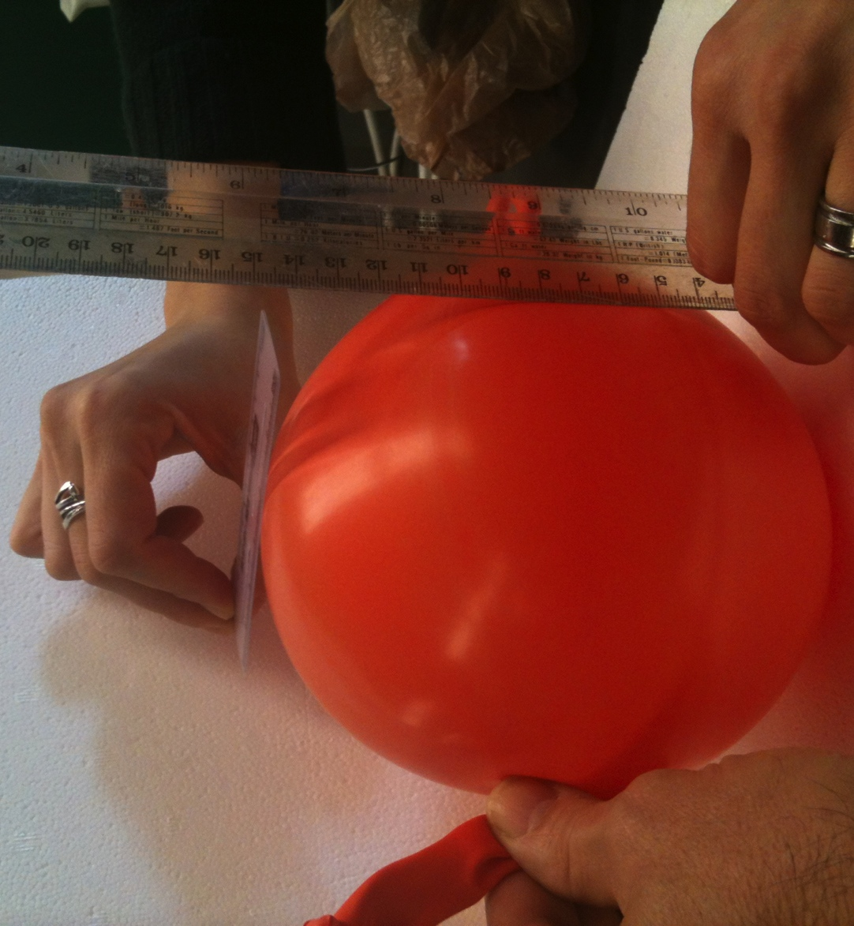
- Repeat 4 more times.
Table 5
 | Diameter (cm) | Volume (cm³)
Trial 1
Trial 2
Trial 3
Average

- Determine the volume of the balloon by using the following formula.
$$Volume=\frac{πd^{3}}{6}$$

- Now determine the volumes for the FVC and TV by a ratio method of your calibrated balloon measures.

For example: Lets say FVC from software area measure was 3568 mV² and the balloon was 2 liters. Then these two volumes should be equal.
$$3568 mV^{2}=2 liters$$

$$\frac{3568 mV^{2}}{2 Liters}=\frac{1784 mV}{1 liter}$$

Calculate the volume in liters for a VC of 1067 mV².

$$\left(1067 mV^{2}\right)\left(\frac{1 liter}{1784 mV^{2}}\right)= 0.6 Liters$$

Now use all the data that you have collected and complete Table 3.

Table 3
Respiratory Parameter | Abbreviation | Units | Experimental (mV²) | Calculated  (L)
Tidal Volume | TV | L
Expired Minute volume | $${\dot{V}}_{E}=TV ×f$$ | L/min
Inspiratory Reserve Volume | IRV | L
Inspiratory Capacity | IC = TV + IRV | L
Expiratory Reserve Volume | ERV | L
Expiratory Capacity | EC = TV + ERV | L
Vital Capacity | VC = IRV + ERV + TV | L

- Which of the following has a more pronounce effect on the ventilatory response: low oxygen or high carbon dioxide? What mechanism is responsible for this response?
- Compare changes in blood chemistry (i.e., pH, CO₂, O₂, etc.) you might experience during exercise. What likely causes the changes in the ventilatory response?
- Do mammals exchange all of their tidal volume (TV)? Why or why not.
- Why don’t dogs or other animals that thermoregulate by hyperventilation create an imbalance in their acid-base status when panting? Can humans pant?
- Why is it important, medically, to measure Tidal volume and Vital capacity 3 times and get an average?
- How might an athlete’s vital capacity compare to that of a non-athlete? Explain.
- Would you predict a difference in tidal volume between smokers and nonsmokers? Explain.

References
Casaburi R. (2005). Factors determining constant work rate exercise tolerance in COPD and their role in dictating the minimal clinically important difference in response to interventions. COPD. 2(1):131-136.

Jorge Alves A, Ribeiro F, Sagiv M, Eynon N, Yamin C, Sagiv M, Oliveira J. (2010). Resting measures and physiological responses to exercise for the determination of prognosis in patients with chronic heart failure: useful tools for clinical decision-making. Cardiol Rev. 18(4):171-177.
Henry RP. (1996). Multiple roles of carbonic anhydrase in cellular transport and metabolism. Annu Rev Physiol 58:523–538.
Lindskog S, Coleman JE. 1973. The catalytic mechanism of carbonic anhydrase. Proc Nat Acad Sci 70:2505–2508.
Samolski D, Ta´rrega J, Anto´n A, Mayos M, Martı´ S, Farrero E, Gu¨ell R. 2010. Sleep hypoventilation due to increased nocturnal oxygen flow in hypercapnic COPD patients. Respirology 15:283–288.
Some text taken directly from ADInstruments protocol guide

